INVESTMENT POTENTIALS OF THE MUNICIPALITY OF BAR

INTRODUCTION

Bar is a cultural, educational, industrial, transportation, and sports center of the South Adriatic coast. It is significant as a dynamic economic hub of Montenegro, while also preserving a rich cultural and historical tradition. Its unique location enables it to serve as the main communication and logistics hub of the Montenegrin Adriatic.

In recent years, the city of Bar has invested significant resources in building overall infrastructure and developing construction land. The local government supports activities aimed at creating a favorable investment environment and enabling the swift implementation of investments.
*SOURCE: www.barinfo.me, www.bwr.me

GEOGRAPHICAL CHARACTERISTICS

The Bar municipality is located in the southeast of Montenegro, between the Adriatic Sea and Lake Skadar, bordered by the municipalities of Podgorica, Budva, Cetinje, and Ulcinj. The city of Bar itself is situated at 42° 6’ latitude and 19° 6’ longitude, at an altitude of four meters. The length of the coastline is 46 km, of which 9 km are beaches.

Bar experiences a Mediterranean climate characterized by long, dry summers and mild, rainy winters. The maximum average monthly temperatures in July are 23.5°C, while the minimum in January is 8.3°C. The swimming season lasts from mid-May to mid-October, during which water temperatures reach up to 26°C. There are few days when the temperature drops below zero. Bar enjoys an average of 208 sunny days annually, significantly more than the number of cloudy (117) and gloomy (40) days.
*SOURCE: www.barinfo.me, www.bar.me, www.visitbar.org
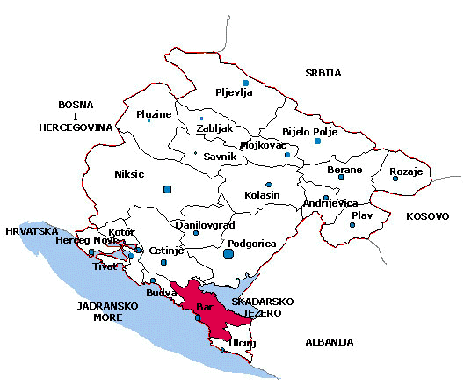
Area (in km²) | 598
*Population | 46.171
Population Density (inhanitants/km²) | 77
Number of Settlements | 87
*Number of Households | 16.362
*Number of Apartments | 42.003
Positive Natural Growth in 2023 | 19
Number of Employed in Montenegro in 2023 | 244.484
Average Salary in Montenegro in 2023 (in EUR) | 987
Net Salary in 2023 | 792
*According to preliminary results of the 2023 census..

*SOURCE: www.monstat.org

MACROECONOMIC INDICATORS

The macroeconomic stability of Montenegro is reflected through various indicators such as GDP, the consumer price index, a balanced state budget, the level of foreign exchange reserves, and more.
1. Gross Domestic Product (GDP)
The high growth of the Gross Domestic Product over the past 3 years (measured by the expenditure approach in current prices) averaged 8.7%.
 | 2021. | 2022.
Gross Domestic Product, market prices (current prices, million EUR) | 4.955,12 | 5.924,02
Gross Domestic Product per capita (€) | 8.002 | 9.598
Real GDP growth (%) | 13,00 | 6,40
*SOURCE: www.monstat.org
2. Inflation Rate
The average annual inflation rate for the year 2023 was 8.6%, measured by consumer prices.
3. Foreign Direct Investment (FDI)
The total inflow of foreign direct investment into Montenegro from the restoration of independence in 2006 to December 31, 2023, amounted to €13.8 billion, according to data from the Central Bank of Montenegro.
The total FDI inflow from 2019 to 2023 amounted to €4.38 billion. Of this amount, €859.9 million was invested in domestic companies and banks, €1.7 billion was recorded as inter-company debt, €1.48 billion was invested in the real estate sector, and €296.9 million in other sectors.
4. Business

Overview of active business entities
Year | Number | Share in relation to the country (%) | Difference in relation to the previous year
2019 | 3188 | 9,2
2020 | 3440 | 9,2 | 7.90%
2021 | 3684 | 9,3 | 7.09%
2022 | 4497 | 9,8 | 22.07%
2023 | 5452 | 10,1 | 21.24%

Overview of the number of business entities by size of business entities
Year | Number | 0-1 emp. | 2-5 emp. | 6-10 emp. | 11-50 emp. | 51-250 emp. | 250 and more
2019 | 2195 | 1215 | 730 | 235 | 6 | 5 | 4
2020 | 2523 | 1494 | 795 | 130 | 91 | 13 | 4
2021 | 2730 | 1644 | 824 | 144 | 105 | 10 | 3
2022 | 3407 | 2230 | 906 | 140 | 115 | 12 | 4

Overview of the number of employees by size of business entities
Year | Number | 0-1 emp. | 2-5 emp. | 6-10 emp. | 11-50 emp. | 51-250 emp. | 250 and more
2019 | 8932 | 1174 | 2071 | 3079 | 375 | 735 | 1498
2020 | 8526 | 1423 | 2235 | 990 | 1853 | 1052 | 973
2021 | 9177 | 1561 | 2333 | 1098 | 2095 | 1100 | 990
2022 | 10596 | 2063 | 2568 | 1072 | 2213 | 1184 | 1496

Activity | 2019 | 2020 | 2021 | 2022
Agriculture, forestry and fishing | 15 | 17 | 18 | 20
Quarrying | 4 | 5 | 6 | 6
Manufacturing | 132 | 146 | 158 | 198
Electricity, gas and steam supply | 1 | 1 | 2 | 3
Water supply and waste water managment | 9 | 10 | 11 | 12
Construction | 226 | 271 | 285 | 338
Wholesale and retail trade and repair of motor vehicles | 564 | 609 | 625 | 733
Transport and storage | 162 | 173 | 173 | 193
Accommodation and food services | 299 | 356 | 389 | 398
Information and communication | 88 | 111 | 133 | 268
Financial and insurance activities | 6 | 7 | 4 | 0
Real estate activities | 93 | 93 | 111 | 144
Professional, scientific and technical activities | 276 | 343 | 393 | 503
Administrative and support service activities | 133 | 156 | 164 | 221
Public administration and defence and compulsory social security insurance | 0 | 0 | 0 | 0
Education | 18 | 21 | 23 | 62
Health and social work | 47 | 48 | 47 | 49
Arts, entertainment and recreation | 35 | 39 | 49 | 75
Other service activities | 87 | 117 | 139 | 184
TOTAL | 2195 | 2523 | 2730 | 3407

BAR | Prosječan broj zaposlenih
Activity | 2019 | 2020 | 2021 | 2022
Agriculture, forestry and fishing | 1.73 | 2.06 | 2.06 | 2.10
Quarrying | 27.75 | 21.20 | 23.83 | 25.67
Manufacturing | 3.68 | 3.57 | 3.59 | 3.30
Electricity, gas and steam supply | 1.00 | 1.00 | 1.00 | 1.33
Water supply and waste water managment | 53.44 | 50.60 | 47.36 | 44.00
Construction | 3.21 | 2.78 | 2.71 | 2.54
Wholesale and retail trade and repair of motor vehicles | 3.56 | 3.24 | 3.24 | 0.30
Transport and storage | 8.93 | 8.21 | 8.08 | 7.52
Accommodation and food services | 4.18 | 3.26 | 3.80 | 3.88
Information and communication | 8.39 | 1.84 | 1.80 | 1.69
Financial and insurance activities | 1.00 | 0.86 | 0.75 | 0.00
Real estate activities | 1.24 | 1.33 | 1.25 | 1.30
Professional, scientific and technical activities | 2.11 | 2.01 | 1.96 | 1.86
Administrative and support service activities | 3.43 | 2.98 | 2.94 | 4.00
Public administration and defence and compulsory social security insurance | 0.00 | 0.00 | 0.00 | 0.00
Education | 3.06 | 3.14 | 2.87 | 1.74
Health and social work | 3.17 | 3.40 | 3.64 | 3.82
Arts, entertainment and recreation | 4.03 | 3.13 | 2.86 | 2.44
Other service activities | 1.83 | 1.79 | 1.62 | 1.35
TOTAL | 4.07 | 3.38 | 3.36 | 2.54

Demographics

 | Live births |  |  | Deaths
 | TOTAL | m | f | TOTAL | m | f | Population growth
2019 | 497 | 264 | 233 | 445 | 242 | 203 | 52
2020 | 487 | 272 | 215 | 472 | 256 | 216 | 15
2021 | 420 | 220 | 200 | 617 | 333 | 284 | -197
2022 | 454 | 213 | 241 | 512 | 270 | 242 | -58
2023 | 489 | 238 | 251 | 470 | 249 | 221 | 19

Population according to censuses
Year | 1948 | 1953 | 1961 | 1971 | 1981 | 1991 | 2003 | 2011 | 2023
Bar | 21487 | 23007 | 24587 | 27580 | 32535 | 37321 | 40037 | 42048 | 45812
Crna Gora | 377189 | 419873 | 471894 | 529604 | 584310 | 615035 | 620145 | 620029 | 623633

The average age of the population is 39.79 years.

OPERATING COSTS
1. Favorable Tax System
Montenegro’s tax system has become one of the most competitive in all of Europe. With corporate income tax rates ranging from 9% to 15%, companies operating in Montenegro can benefit from low tax burdens, which is an important factor for maximizing their operating profits.
Overview of tax rates in Montenegro:
TAXES | TAX RATE
VAT | Standard rate - 21%  Reduced rate - 7%
Corporate Tax | Progressive Rates  - Up to €100,000.00: 9%  - From €100,000.01 to €1,500,000.00: €9,000.00 + 12% on the amount over €100,000.01  - Over €1,500,000.01: €177,000.00 + 15% on the amount over €1,500,000.01
Personal Income Tax | Progressive Rates  1. On Personal Income:  - 0% on taxable income up to €700.00  - 9% on taxable income from €700.01 to €1,000.00  - 15% on taxable income over €1,000.01  2. On Income from Self-Employment:  - 9% on taxable income from €8,400.01 to €12,000.00  - 15% on taxable income over €12,000.01  3. On Other Income (from property, capital, capital gains, royalties, etc.):  - 15% of the taxable base.
Property Transfer Tax | Progressive Rates:  - Up to €150,000: 3%;  - Over €150,000.01: €4,500 + 5% on the amount exceeding €150,000.01;  - Over €500,000.01: €22,000 + 6% on the amount exceeding €500,000.01.
Municipal Taxes, Fees, and Charges

- Fee for Communal Equipment of Construction Land (€ per m² of Gross Floor Area)
ZONE | FEE
I | 126,00
II | 112,00
III | 98,00
IV | 70,00
V | 56,00
VI | 42,00
VII | 0,00
Decision on Fees for Communal Equipment of Construction Land (“Official Gazette of Montenegro – Municipal Regulations”, No. 38/20)
b) Fees for the Use of Municipal Roads
Fee for Extraordinary Transport
For exceeding the prescribed length of a vehicle or a vehicle combination, the fee is:
• For exceedances greater than 5% up to ≤ 20%: €0.10/km,
• For exceedances greater than 20%: €0.20/km.
For exceeding the prescribed width of a vehicle or a vehicle combination, the fee is:
• For exceedances from 0.01 m to ≤ 0.50 m: €0.10/km,
• For exceedances from 0.51 m to ≤ 1.50 m: €0.20/km,
• For exceedances greater than 1.50 m: €0.30/km.
For exceeding the prescribed height of a vehicle or a vehicle combination, the fee is:
• For exceedances from 0.01 m to ≤ 0.50 m: €0.10/km,
• For exceedances greater than 0.50 m: €0.20/km.
Annual Fee for Renting Road Land and Other Land Belonging to the Road
The amount of the annual fee depends on the category of the road:

• Streets within settlements: €4.90/m²,
• Sections of state roads passing through settlements: €4.00/m²,
• Local roads: €3.90/m².
The amount of this fee, depending on the area of the used road land, is adjusted with the following coefficients:
• Coefficient 0.90 for an area of 51 to 100 m²,
• Coefficient 0.80 for an area of 101 to 300 m²,
• Coefficient 0.70 for an area over 300 m².

The amount determined according to paragraphs 2 and 3 of this article is established as the starting value in public bidding for the lease of road land.
Fee for the Installation of Pipelines, Water Supply, Sewage, Electric Lines, Electronic Communication Lines, Gas Pipelines, and Oil Pipelines on the Road
The fee for installing pipelines, water supply, sewage, electric lines, electronic communication lines, gas pipelines, and oil pipelines in the road body, depending on the road category, is:
• Streets within settlements: €5.90/m,
• Sections of state roads passing through settlements: €5.90/m,
• Local roads: €3.00/m.
The amount of the fee, depending on the length of the used road body, is adjusted:
• Coefficient 0.90 for a total length of 1001-3000 m,
• Coefficient 0.80 for a total length of 3001-5000 m,
• Coefficient 0.70 for a total length over 5000 m.
The fee for installing pipelines, water supply, sewage, electric lines, electronic communication lines, gas pipelines, and oil pipelines outside the road body using the road belt and other land belonging to the road, depending on the road category, is:
• Streets within settlements: €2.00/m,
• Sections of state roads passing through settlements: €2.00/m,
• Local roads: €1.00/m.
The amount of this fee, depending on the length of the used road belt and other land belonging to the road, is adjusted:
• Coefficient 0.90 for a total length of 1001 to 3000 m,
• Coefficient 0.80 for a total length of 3001 to 5000 m,
• Coefficient 0.70 for a total length over 5000 m.
The fee for the installation and usage of standalone infrastructure elements connected with pipelines, water supply, sewage, electric lines, electronic communication lines, gas pipelines, and oil pipelines, such as substations, base stations, antenna masts, and pumping stations, is determined based on the area used and amounts to:
• For an area up to 5 m²: €500,
• For an area from 5 m² to 10 m²: €1000,
• For an area from 10 m² to 20 m²: €2000,
• For an area larger than 20 m²: €3000.

Fee for Installations Involving Trenching or Other Works (Pipe Pressing, etc.) Crossing the Road
The amount of the fee depends on the road category:
• Streets within settlements: €990 per trench,
• Local roads: €790 per trench.

Annual Fee for Installed Infrastructure

The annual fee for pipelines, water supply, sewage, electric lines, electronic communication lines, gas pipelines, and oil pipelines installed on the road, along with related infrastructure (substations, base stations, antenna masts, pumping stations, etc.), amounts to 15% of the amounts determined in the manner described above.

Annual Fee for the Use of Commercial Facilities with Road Access
The annual fee is determined based on the road category, facility area, and the type of activity conducted in the facility. The fee is as follows:
- Streets within settlements:
1.1 Fuel stations with auxiliary facilities: €3000,
1.2 Storage and warehousing facilities:
• Up to 50 m²: €100,
• 50 m² to 200 m²: €200,
• Over 200 m²: €400,
1.3 Banks, insurance companies, and other financial organizations, fixed, mobile, and cable operators:
• Up to 50 m²: €200,
• 50 m² to 200 m²: €400,
• Over 200 m²: €500,
1.4 Law offices, notaries, enforcement offices, health and veterinary institutions, accounting and administrative service organizations, etc.:
• Up to 50 m²: €100,
• 50 m² to 200 m²: €200,
• Over 200 m²: €300,
1.5 Post offices:
• Up to 50 m²: €200,
• 50 m² to 200 m²: €400,
• Over 200 m²: €500,
1.6 Hospitality facilities:
• Up to 50 m²: €150,
• 50 m² to 200 m²: €200,
• Over 200 m²: €300,
1.7 Hotels and motels:
• Up to 50 beds: €500,
• Over 50 beds: €700,
1.8 Commercial facilities:
• Up to 50 m²: €100,
• 50 m² to 200 m²: €200,
• 200 m² to 500 m²: €400,
• Over 500 m²: €600,
1.9 Motor vehicle servicing and washing facilities:
• Up to 50 m²: €100,
• 50 m² to 200 m²: €150,
• Over 200 m²: €200,
1.10 Other facilities for trade, crafts, services, and similar activities, including temporary modular facilities such as kiosks that do not pay local municipal fees:
• Up to 50 m²: €50,
• 50 m² to 200 m²: €100,
• Over 200 m²: €150,
1.11 Facilities for organizing lottery games (lottery, instant lottery, bingo, TV tombola, etc.):
• Up to 50 m²: €200,
• 50 m² to 100 m²: €300,
• Over 100 m²: €500,
1.12 Facilities for organizing special games of chance (casinos, betting games, slot machine games):
• Up to 100 m²: €300,
• Over 100 m²: €500.
2. Sections of state roads passing through settlements:
2.1 Fuel stations with auxiliary facilities: €3000,
2.2 Storage and warehousing facilities:
• Up to 50 m²: €100,
• 50 m² to 200 m²: €200,
• Over 200 m²: €400,
2.3 Banks, insurance companies, and other financial organizations, fixed, mobile, and cable operators:
• Up to 50 m²: €200,
• 50 m² to 200 m²: €400,
• Over 200 m²: €500,
2.4 Law offices, notaries, enforcement offices, health and veterinary institutions, accounting and administrative service organizations, etc.:
• Up to 50 m²: €100,
• 50 m² to 200 m²: €200,
• Over 200 m²: €300,
2.5 Post offices:
• Up to 50 m²: €200,
• 50 m² to 200 m²: €400,
• Over 200 m²: €500,
2.6 Hospitality facilities:
• Up to 50 m²: €150,
• 50 m² to 200 m²: €200,
• Over 200 m²: €300,
2.7 Hotels and motels:
• Up to 50 beds: €500,
• Over 50 beds: €700,
2.8 Commercial facilities:
• Up to 50 m²: €100,
• 50 m² to 200 m²: €200,
• 200 m² to 500 m²: €400,
• Over 500 m²: €600,
2.9 Motor vehicle servicing and washing facilities:
• Up to 50 m²: €100,
• 50 m² to 200 m²: €150,
• Over 200 m²: €200,
2.10 Other premises where trade, craft, service, and other similar activities are conducted, as well as temporary prefabricated structures like kiosks, for which local utility taxes are not paid:
- up to 50 m² - €50;
- from 50 m² to 200 m² - €100;
- over 200 m² - €150;
2.11 Premises where lottery games of chance are organized (lotteries, express and instant lotteries, bingo, TV tombola and closed-type tombola, lotto, keno, sports betting, toto, additional games on lotto and toto, video lottery, fonto, and other similar games of chance with draws):
- up to 50 m² - €200;
- from 50 m² to 100 m² - €300;
- over 100 m² - €500;
2.12 Premises where special games of chance are organized (casino games, betting games, slot machine games):
- up to 100 m² - €300;
- over 100 m² - €500.
3) Local roads
3.1 For fuel stations with accompanying facilities for supplying motor vehicles - €2,500;
3.2 Warehouses and depots intended for storage and sale of goods:
- up to 50 m² - €80;
- from 50 m² to 200 m² - €150;
- over 200 m² - €350;
3.3 Banks, insurance companies, and other financial organizations, fixed, mobile, and cable operators:
- up to 50 m² - €150;
- from 50 m² to 200 m² - €350;
- over 200 m² - €450;
3.4 Law offices, notary offices, enforcement offices, healthcare and veterinary institutions, organizations providing accounting and administrative services, etc.:
- up to 50 m² - €50;
- from 50 m² to 200 m² - €100;
- over 200 m² - €150;
3.5 Post offices:
- up to 50 m² - €150;
- from 50 m² to 200 m² - €200;
- over 200 m² - €300;
3.6 Hospitality establishments:
- up to 50 m² - €100;
- from 50 m² to 200 m² - €150;
- over 200 m² - €200;
3.7 Hotels and motels:
- up to 50 beds - €350;
- over 50 beds - €500;
3.8 Commercial premises:
- up to 50 m² - €70;
- from 50 m² to 200 m² - €100;
- from 200 m² to 500 m² - €300;
- over 500 m² - €400;
3.9 Premises for servicing and washing motor vehicles:
- up to 50 m² - €80;
- from 50 m² to 200 m² - €100;
- over 200 m² - €150;
3.10 Other premises where trade, craft, service, and similar activities are conducted, as well as temporary prefabricated structures like kiosks, for which local utility taxes are not paid:
- up to 50 m² - €50;
- from 50 m² to 200 m² - €80;
- over 200 m² - €100;
3.11 Premises where lottery games of chance are organized (lotteries, express and instant lotteries, bingo, TV tombola, and closed-type tombola, lotto, keno, sports betting, toto, additional games on lotto and toto, video lottery, fonto, and other similar games of chance with draws):
- up to 50 m² - €150;
- from 50 m² to 100 m² - €200;
- over 100 m² - €300;
3.12 Premises where special games of chance are organized (casino games, betting games, slot machine games):
- up to 100 m² - €200;
- over 100 m² - €400.
The annual fee for setting up and using commercial premises of a seasonal or temporary nature (kiosks, caravan vehicles, mobile stores) amounts to €100.
Decision on fees for the use of municipal roads in the territory of the Municipality of Bar ("Official Gazette of Montenegro - Municipal Regulations", no. 22/23 of 05.05.2023).
c) Local utility taxes
For the use of public spaces to set up temporary structures intended for tourism and hospitality (temporary hospitality premises, hospitality terraces, refrigerated and display cabinets for selling food and drinks, ice cream conservators, hospitality machines, open bars, special vehicles for providing simple hospitality services), the amount of the utility tax is determined monthly per square meter of the space used:
- Zone I: €13.75
- Zone II: €12.40
- Zone III: €11.00
- Zone IV: €9.65
- Zone V: €6.90
- Zone VI: €5.50.
The utility tax for using space for setting up temporary hospitality premises and hospitality terraces is reduced by 65%.
The utility tax under this tariff item cannot be determined for a period shorter than four months.
II For the use of space for organizing an auto camp, the amount of the utility tax is determined monthly per square meter of the space used, at a rate of €1.50.
The utility tax under this tariff item cannot be determined for a period shorter than four months.
III For the use of public spaces for setting up temporary structures intended for trade and services:
- Sales panels and sales counters, stands, kiosks, ATMs, markets, trade and service facilities: the amount of the utility tax is determined monthly per square meter of the space used:
Zone I: €11.45
Zone II: €10.30
Zone III: €9.20
Zone IV: €8.00
Zone V: €5.75
Zone VI: €4.60.
- Lots for car sales: the amount of the utility tax is determined monthly per square meter of the space used, at a rate of €0.50.
IV For the use of public spaces to set up temporary structures intended for event organization (information point, tent for events or promotions, stage, platform or open-air cinema, structures and equipment for filming music videos, films, or advertisements, structures and equipment for organizing festivals, and structures and equipment for holiday and other public events), the amount of the utility tax is determined monthly, or proportionally to the time of use, per square meter of the space used: €15.00.
V For the use of public spaces to set up temporary structures intended for sports and recreation (structures for renting sports and recreational equipment, covered/indoor sports facilities, open-air sports facilities, amusement parks, playgrounds, mobile ice rinks, go-kart tracks), the amount of the utility tax is determined as follows:
- For the use of a covered/indoor sports facility and open-air field, a local utility tax is paid annually per square meter: €2.50.
- For the use of an amusement park, playground, mobile ice rink, go-kart track, etc., the utility tax is paid monthly per square meter: €1.00.
The utility tax under this tariff number is paid proportionally to the time of use of the space on public surfaces.
VI For the use of public spaces for:
- conducting construction work,
- excavation, except along streets and municipal and unclassified roads in general use,
- depositing construction and other materials,
- installing wooden and metal structures, and placing vehicles for the purpose of performing construction work, except for:
- work related to the reconstruction of a municipal road,
- work carried out under a public-private partnership agreement concluded with the Municipality of Bar or public services founded by the Municipality of Bar, and the use of public space for the installation of access ramps, stairs, elevators, vertical-lift platforms, and inclined-lift folding platforms for the access and movement of persons with reduced mobility and persons with disabilities, the tax is determined daily per square meter of occupied space: €0.30.
VII For the use of a prefabricated facility for vehicle servicing or washing, the utility tax is paid monthly per square meter: €1.30.
Tariff Number 2
I For the use of public spaces to set up temporary structures intended for advertising, promotion, and providing information (advertising and promotional panels, billboards, video boards, displays, promotional signs, sculptures and pavilions, advertising flags, and other advertisements), the amount of the utility tax is determined as follows:
1) For the use of an advertising and promotional panel, billboard (single-sided, double-sided, or triple-sided), and other advertisements, the utility tax is paid annually per square meter, depending on the developed advertising surface, or proportionally to the time of use:
- up to 5.00 m²: €85.00
- from 5.1 m² to 10.0 m²: €70.00
- from 10.1 m² to 20.0 m²: €60.00
- from 20.1 m² to 30.0 m²: €50.00
- from 30.1 m² to 50.0 m²: €45.00
- over 50.1 m²: €40.00.
For the listed temporary structures connected to public lighting for electricity, the fee is increased by:
€100.00 for connections up to 200W,
€200.00 for connections from 201W to 400W,
€300.00 for connections from 401W to 600W.
2) For the use of video billboards and display advertisements, a utility tax of €5,000.00 is paid annually.
3) For the use of advertising banners and banners for promotion (mesh fabrics, tarps, etc.), advertising flags (on masts, poles) above municipal and unclassified roads and other public spaces, a utility tax of €2.50 per m² is charged.
The tax from point 3) is determined on a monthly basis.
The utility tax under this tariff number for the first year of use is paid upon the submission of a request to the Secretariat for Finance, based on the issued urban planning conditions by the Secretariat for Urban Planning and Spatial Planning.
Tariff Number 3
I For the use of public spaces to set up temporary structures intended for communal services and infrastructure (temporary parking, taxi stands):
1) For the use of space for temporary parking, a utility tax is paid monthly per designated parking spot:
a) for parking of cargo vehicles: €25.00
b) for parking of passenger vehicles: €5.00.
2) For the use of a taxi stand, the tax per taxi vehicle is determined based on the issued license extract, at a monthly rate of €5.00.
The tax from this tariff number, point 2), is paid by the legal entity or entrepreneur engaged in taxi transportation.

b) Property Tax
The basis for determining the property tax is the market value of the property on January 1st of the year for which the tax is being assessed. The market value of the property is determined by multiplying the area of the property by the average market price per m² in the Municipality of Bar and is adjusted by a coefficient for location, quality, and age of the building in accordance with the law governing property tax. The tax rates are prescribed based on the type of property for:
Buildings:
- Residential building: 0.26%
- Secondary residential building: 0.60%
- Auxiliary building, non-residential space, garages, and garage spaces: 0.25%
- Production facility: 0.25%
- Storage space: 0.30%
- Tanks (for fuel, bulk, and liquid cargo): 1%
- Commercial building and commercial space: 0.40%
- Building under construction: 0.30%
- Immovable temporary structure: 0.30%
- Energy facilities (wind farms, wind turbines, solar panels, substations), telecommunications, and similar: 1%.
Land:
- Building land: 0.30%
- Agricultural land: 0.25%
- Forest and other land: 0.25%.
Decision on Property Tax ("Official Gazette of Montenegro - municipal regulations," no. 51/19, 57/23, 05/24)

3. Operational Costs

Business operations in Montenegro involve lower prices compared to most other European countries, while the quality of services provided is at a competitive level. Some of the basic indicators of operational costs are shown in the table below.

Average Monthly Salary | 792 EUR
The share of personal income tax and contributions for mandatory social insurance in gross earnings is 21% for the minimum wage and 22% for the average wage. | 21-22%
Office Rental Prices (monthly) | 200-700€
Residential Space Rental Prices (monthly) | 300-700€
Average Electricity Price | 0,1046 kWh
* Source: www.mia.co.me (Montenegrin Investment Agency)

PRICE LIST OF COMMUNAL SERVICES
LLC “Water Supply and Sewerage” Bar
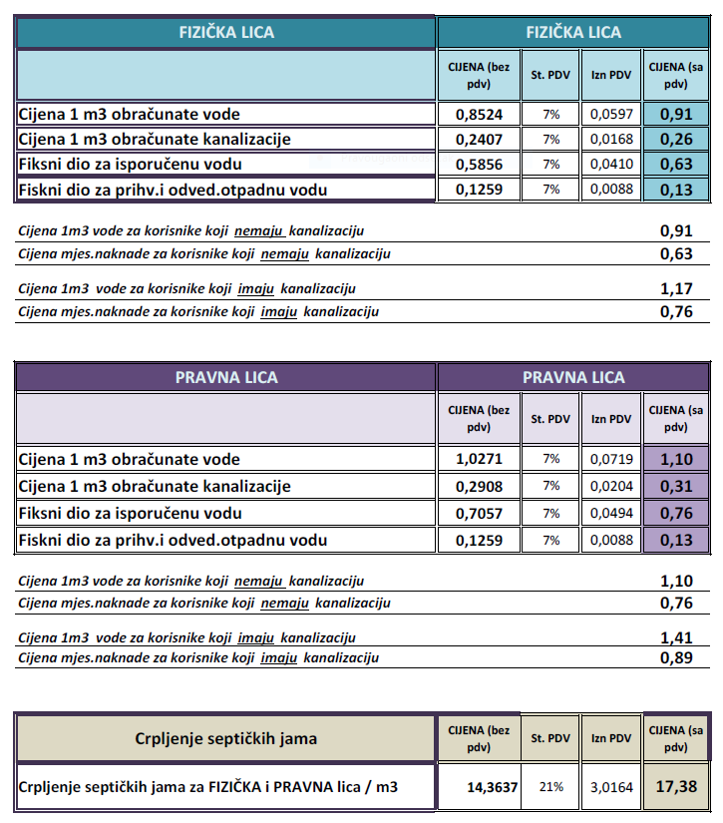

http://www.vodovod-bar.me/va%C5%BEni-dokumenti/cjenovnik-o-vodosnabdijevanju-i-upravljanju-komunalnim-otpadnim-vodama/

Prices for Connection to the Water Supply and Sewerage Network

CONNECTION TO THE WATER SUPPLY NETWORK
INSTALLATION OF PIPE CLAMPS
 | PROFILE | PRICE (€)
1 | 50-100mm | 80,00
2 | 125-200mm | 160,00
3 | 250-400mm | 315,00
INSTALLATION OF SOCKET FITTINGS - WITH CUSTOM PIECES IN THE EXISTING NETWORK
 | PROFILE | PRICE (€)
1 | 1/2“ - 1” | 80,00
2 | 5/4“ - 2” | 160,00
3 | 75-100mm | 210,00
4 | 125-200mm | 260,00
5 | 250-300mm | 315,00
6 | 350-400mm | 390,00
7 | 450-500mm | 590,00
INSTALLATION OF WATER METERS, CHECK VALVES, AND PRESSURE REDUCERS WITH FITTINGS
 | PROFILE | PRICE (€)
1 | 1/2”-3/4“ | 25,00
2 | 1”-6/4“ | 40,00
3 | 50-100mm | 100,00
4 | 125-200mm | 160,00
5 | 250-300mm | 180,00
REMOVAL OF WATER METERS WITH FITTINGS
R.BR | PROFILE | PRICE (€)
1 | 1/2“-3/4“ | 15,00
2 | l”-6/4” | 20,00
3 | 50-100mm | 50,00
4 | 125-200mm | 80,00
5 | 250-300mm | 90,00
INSTALLATION OF PH HD PIPES PER METER
 | PROFILE | PRICE (€)
1 | 25-32mm | 0,55
2 | 40-50mm | 0,65
3 | 63mm | 1,05
4 | 90mm | 1,55
5 | 110mm | 1,70
COSTS OF TECHNICAL EXPERT VISIT
 | SERVICE | PRICE (€)
1 | Visit of a Technical Expert to the Site and Processing of the Water Supply Connection Application | 40,00
REGISTRATION OF WATER METERS IN FACILITIES
 | PROFILE | PRICE (€)
1 | 1/2“-3/4" | 60,00
2 | 1"-6/4“ | 80,00
3 | 50-100mm | 200,00
4 | > l00mm | 325,00
ENGAGEMENT OF WORKFORCE ON THE WATER SUPPLY NETWORK
 | QUALIFICATION | GROSS HOUR (€)
1 | NK - I | 5,80
2 | KV | 6,90
3 | VKV | 10,38
4 | SSS | 11,55
5 | VSS | 14,25
EXECUTION OF CONNECTION TO THE SEWERAGE SYSTEM
INSTALLATION OF SEWER PIPES
 | PROFILE | PRICE (€)
1 | 100mm | 5,50
2 | 150mm | 6,50
3 | 200mm | 8,00
4 | 300mm | 10,50
5 | 400mm | 15,00
6 | 500mm | 20,00
COSTS OF TECHNICAL EXPERT VISIT
 | SERVICE | PRICE (€)
1 | Visit of a Technical Expert to the Site and Processing of the Sewer Connection Application | 40,00
2 | Supervision of the connection to the sewerage system is charged through the engagement of appropriate workforce as outlined in point 3 of this article.
ENGAGEMENT OF WORKFORCE ON THE SEWER NETWORK
 | QUALIFICATION | GROSS HOUR (€)
1 | NK - I | 8,70
2 | KV | 10,35
3 | VKV | 15,57
4 | SSS | 17,30
5 | VSS | 21,40

LLC “Communal Services” Bar

Price List for Waste Management Services
Service charges will be calculated based on the area of residential or business space expressed in m².
No. | Service User | Price | Correction Factor | Price with Included Correction Factor
No. | Service User | €/m² | k=1,00-10,00 | €/m²
I | Individuals
1 | Residential Fund | 0,08 |  | 0,08
2 | Individual Fund | 0,08 |  | 0,08
II | Legal Entities |  |  | 0,00
1 | Facilities of State and Local Authorities and Institutions (Ministry of Interior, Customs, Courts, Prosecutor's Offices, Inspections, Consulates, Port Authority, Social Work Center, Employment Bureau, Pension Fund, etc.) | 0,08 | 4,50 | 0,36
2 | Healthcare
2.1 | Hospitals | 0,08 | 6,50 | 0,52
2.2 | Health Centers | 0,08 | 4,50 | 0,36
2.3 | Polyclinics | 0,08 | 4,50 | 0,36
2.4 | Clinics, Medical and Dental Offices, Laboratories, Pharmacies, Nursing Homes, Veterinary Institutions | 0,08 | 9,00 | 0,72
3 | Education - Schools and Preschool Institutions | 0,08 | 2,00 | 0,16
4 | Cultural Facilities (Cultural Center, Cinemas, Museums, Galleries, Information Centers, Libraries) | 0,08 | 3,00 | 0,24
5 | Sports Facilities (Sports Halls, Gyms, Fitness Centers, Inflatable Halls, Outdoor and Indoor Courts, etc.) | 0,08 | 3,00 | 0,24
6 | Industry |  |  | 0,00
6.1 | Energy Facilities | 0,08 | 5,50 | 0,44
6.2 | Post and Telecommunications Facilities (Radio and TV Operators, Fixed and Mobile Telephony) | 0,08 | 5,50 | 0,44
6.3 | Production and Processing of Food and Agricultural Products (Factories, Halls, Plants, and Other Spaces for Production Activities) | 0,08 | 5,50 | 0,44
6.4 | Industrial Production and Construction (Production of Construction Materials, PVC and ALU Products, Factories and Plants for Concrete, Stone, Marble, Metal, etc.) | 0,08 | 3,50 | 0,28
6.5 | Facilities Under Construction or Reconstruction - Construction Sites | 0,08 | 3,50 | 0,28
6.6 | Auto Parts, Car Sales Lots | 0,08 | 3,50 | 0,28
6.7 | Warehouses, Depots, Storage Spaces, Hangars, Distribution Centers, Parking Spaces, and Garages, etc. | 0,08 | 3,50 | 0,28
7 | Crafts
7.1 | Carpentry and Glassworking Shops | 0,08 | 10,00 | 0,80
7.2 | Auto Repair Shops, Car Washes, Tire Shops, Car Rentals, Vehicle Registrations, Locksmith and Sheet Metal Shops, etc. | 0,08 | 10,00 | 0,80
7.3 | Hair Salons, Beauty Salons, Photographers, Florists, Bookstores, Copy Shops, Jewelers, Service Shops, Dry Cleaners, Laundries, Tailoring Shops, Shoemakers, Opticians, Watchmakers, Souvenir Shops, Driving Schools, etc. | 0,08 | 10,00 | 0,80
7.4 | Internet Cafés, Computer Game Rooms, Betting Shops, Slot Clubs | 0,08 | 9,00 | 0,72
8 | Tourism
8.1 | Hotels, Motels, Hostels, Resorts, and Campsites | 0,08 | 10,00 | 0,80
9 | Hospitality (Restaurants, Pizzerias, Burek Shops, Grill Houses, Community Kitchens, Bakeries, Fast Food Outlets, Taverns, Cafés, Buffets, Wineries, Bars, Pastry Shops, Pubs, Outdoor Bars, Nightclubs, Discotheques, etc.) | 0,08 | 10,00 | 0,80
10 | Trade
10.1 | Retail (Minimarkets, Megamarkets, Greengrocers, Butchers, Discount Stores, Gas Stations, etc.) | 0,08 | 10,00 | 0,80
10.2 | Wholesale (Discount Stores, Shopping Centers, etc.) | 0,08 | 9,00 | 0,72
10.3 | Boutiques and Other Retail Outlets up to 40 m² | 0,08 | 9,00 | 0,72
10.4 | Stores for Technical Goods, Electrical and Plumbing Supplies, Furniture Stores, General Merchandise Stores | 0,08 | 9,00 | 0,72
11 | Office Space for Providing Administrative Services (Banks, Lawyers, Notaries, Organizations, Clubs, Associations, etc.)
11.1 | do 50m² | 0,08 | 9,00 | 0,72
11.2 | od 51-200m² | 0,08 | 7,00 | 0,56
11.3 | od 201-1.000m² | 0,08 | 4,50 | 0,36
11.4 | preko 1.000m² | 0,08 | 3,50 | 0,28
 | Temporary Structures - Seasonal Character
12 | Coastal Property - Beaches - Contracts | Container | Container
13 | Tourist Accommodation - Apartments | 0,08 | 10,00 | 0,80
14 | Hotels, Resorts with Economic Courtyards | Container | Container
15 | Typical Structures
15.1 | For Sale of Mixed Goods - Tobacco, Print, Souvenirs, Costume Jewelry, etc. | 0,08 | 9,00 | 0,72
15.2 | Hospitality: (Fast Food, Grills, Refrigerated Displays for Ice Cream and Beverages, etc.) | 0,08 | 10,00 | 0,80
16 | Terraces
16.1 | Open Areas - Uncovered | 0,08 | 10,00 | 0,80
16.2 | Covered Open Areas | 0,08 | 10,00 | 0,80
16.3 | Enclosed Areas | 0,08 | 10,00 | 0,80
17 | Depositing Municipal Waste | 0,02 |  | 0,02

Waste Collection by Volume
For legal entities engaged in business activities and having economic yards within their facilities, as well as for commercial entities where both the user and the service provider express mutual interest, the service charge will be based on the volume of municipal waste collected or the volume of waste containers (bins) measured in cubic meters (m³):
Container Type  (Volume in liters) | 1.100 liters  1,1m³ | 5.000 liters  5m³ | 7.000 liters  7m³ | Bell Container2-3m³
Price - € | 40,00 | 200,00 | 200,00 | 120,00

Secondary Properties, Weekend Houses, and Weekend Apartments
Usage Period: The price is increased by 100% with the provided proof for the period when the property is not in use.
Public Events
Waste Management: For waste collection, cleaning, and washing of surfaces used for public events lasting one or more days, services are contracted between the event organizer and the company.
Seasonal Properties
Seasonal Services: Services provided from June to September are increased by 100%.
Waste Disposal
Municipal Waste: Disposal charges apply to all service users and are calculated per m² of usable area.

Other Waste Management Services not covered by this price list will be charged according to the rates established for similar services in the relevant price list by type and activity.

Note: Service prices are listed excluding VAT.

MARKET POTENTIAL

CEFTA Agreement
Trade Access: Companies operating in Montenegro benefit from duty-free access to the Southeast European market, one of the fastest-growing regions in Europe. This regional agreement, signed among Albania, Bosnia and Herzegovina, Croatia, Serbia, North Macedonia, Moldova, and UNMIK Kosovo, provides free access to a market of approximately 30 million people.
Free Trade Agreement with Russia
Market Access: The free trade agreement signed with Russia in 2000 makes Montenegro particularly attractive to foreign investors by granting access to a market of around 150 million consumers.
EU Agreement
Tariff-Free Access: The agreement with the European Union allows Montenegrin products to enter the EU market tariff-free for over 95% of goods originating from Montenegro, without quantitative restrictions.

TRANSPORT INFRASTRUCTURE
Maritime Transport
Port of Bar
Overview: The Port of Bar is the main Montenegrin seaport, handling nearly all imported goods. It has significant comparative advantages over Northern Adriatic ports, reducing transit times and creating savings in maritime transport costs. Integrated with the Beograd-Bar railway line and the road network, the port is a crucial link in the intermodal transport chain.
Free Zone: The Free Zone Port of Bar encompasses the entire port area, with “Luka Bar” AD serving as the operator for both the free zone and the container terminal and general cargo area. The total area for free zone operations by both companies exceeds 130 hectares.
Cost Efficiency: Adopting cost-effective principles and modern management concepts, the port offers a balanced and competitive pricing policy aimed at achieving high user satisfaction with port services.
Marina Bar
Marina Bar is the first and largest nautical and tourist center located at the entrance to the Adriatic Sea, 104 nautical miles from Otranto. The marina covers an area of 148,000 m², with facilities including 660 sea berths, 250 dry land berths, a fuel station, a service hangar, and parking space. The operational quay length is 3,700 meters. It is situated in the city center, close to the historic core and commercial zone.
Marina Bar offers multiple advantages over its competitors, including a favorable location, high service standards, technical and staff readiness, a high level of security, and attention to the well-being of people and property.

Railway Traffic
Beograd–Bar Railway
The freight railway operator in Montenegro is the joint-stock company “Montecargo” Podgorica. It provides services for conventional and combined transport, hazardous materials transport, special consignments, and wagon leasing.

Montecargo is a member of several international organizations important for the development of the railway market and regulation, including:
• CER – Community of European Railways and Infrastructure Managers
• UIC – International Union of Railways
• CIT – International Rail Transport Committee
• FTE – Forum Train Europe
Montenegro is a member of the international organization OTIF – Intergovernmental Organization for International Carriage by Rail.
Aviation Traffic
Podgorica Airport
Tivat Airport

INVESTMENT INCENTIVES

Fiscal Benefits
Fee for Communal Equipment of Construction Land
If the fee for communal equipment of construction land is paid in full within fifteen days of signing the contract, the investor is entitled to a 20% discount on the calculated fee.
The fee for communal equipment of construction land is reduced by:
• 50% for residential buildings with a net area up to 200 m².
• 20% for residential buildings with a net area over 200 m².
• 80% for buildings in business zones.
• 50% for open space on a parcel designated for activity.
• 10% for facilities intended for new employment of more than 10 people.
• 100 euros per m² for solar collectors for the building, up to a maximum of 50% of the calculated fee.
• 70% for converting parts of a residential building into business premises or vice versa.
• 50% for attics.
• 50% for reconstruction or demolition of an existing building and construction of a new one within the existing dimensions if additional communal equipment is needed.
• 80% for the reconstruction of buildings listed in the cultural heritage registry.
• 65% for standalone garage buildings.
• 80% for above-ground garages within buildings.

HUMAN RESOURCES

PLAN INVESTICIONIH LOKACIJA

Scope of the Detailed Urban Plan "Topolica III"
("Official Gazette of Montenegro" – Municipal Regulations No. 82-23)

1.1. Urban Plot No. 2 in Zone "A", Urban Block 1
Textual part of the plan, pages 62-64
- Lot area: | 17.975 m2
- Purpose: | Tourism T1-Hotel
- Maximum number of floors : | 10 above-ground floors
- Lot coverage area: | 7.190 m2
- Maximum GBA* object: | 62.912 m2
- The initial price for land sale | _____ €/m2
- The utility for structure is €126.00 per m2 NBA*
- The location is fully equipped with utilities.
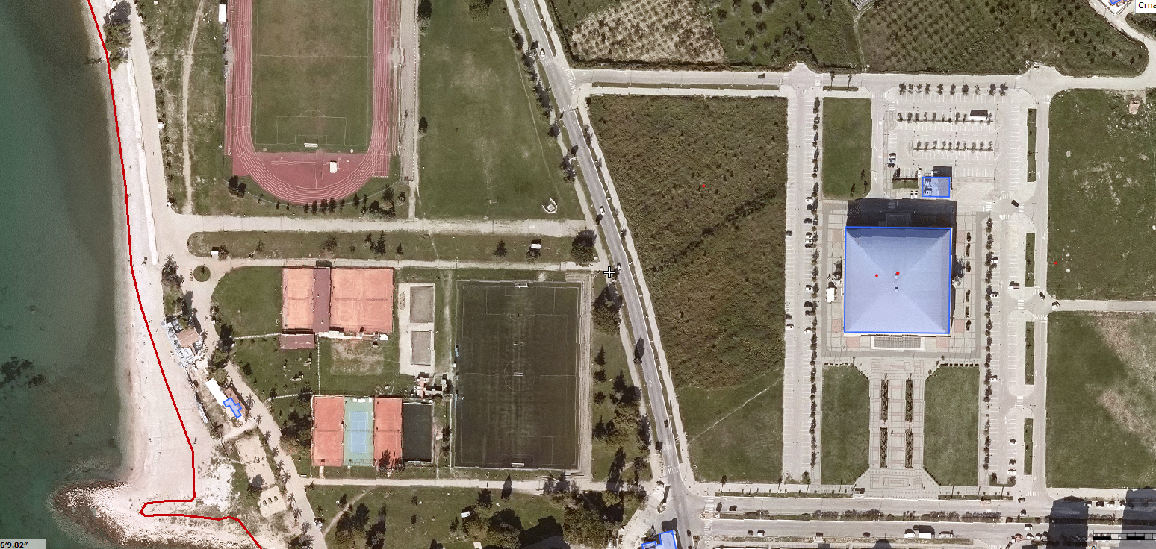
UP 2 Examples of Hotel Facilities

  - Urbanistička parcela broj 44 u zoni "C", urbanistički blok 8
Tekstualni dio plana strane 65-67
- Lot area: | 17.372 m2
- Purpose: | central activities - multifunctional shopping center
- Maximum number of floors : | P+1
- Lot coverage area: | 6.949 m2
- Maximum GBA* object: | 13.898 m2
- The initial price for land sale | 233,60 €/m2
- The utility for structure is €126.00 per m2 NBA*
- The location is fully equipped with utilities.
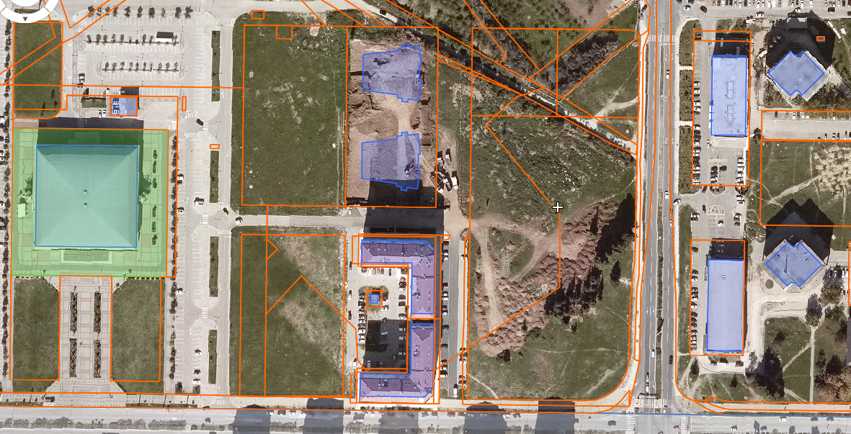
UP 44

Scope of the Detailed Urban Plan "Topolica-Bjeliši"
("Official Gazette of Montenegro" – Municipal Regulations No. 32/16)
1.1 Urban parcel number 52 in zone "C", urban block 3
Textual part of the plan, table on page 100
- Lot area: | 2.976 m2
- Purpose: | central activities
- Maximum number of floors : | 5-9 upper floor
- Lot coverage area: | 1.190 m2
- Maximum GBA* object: | 10.416 m2
- The initial price for land sale | €/m2
- The utility for structure is €126.00 per m2 NBA*
- The location is fully equipped with utilities.
1.2 Urban parcel number 57 in zone "C", urban block 3
Textual part of the plan, table on page 100
- Lot area: | 2.562 m2
- Purpose: | central activities
- Maximum number of floors : | 5-9 upper floor
- Lot coverage area: | 1.025 m2
- Maximum GBA* object: | 8.967 m2
- The initial price for land sale | €/m2
- The utility for structure is €126.00 per m2 NBA*
- The location is fully equipped with utilities.

1.3 Urban parcel number 58 in zone "C", urban block 3
Textual part of the plan, table on page 100
1.3. Building lot number 58 in zone "C", block 3
- Lot area: | 2.739 m2
- Purpose: | central activities
- Maximum number of floors : | 5-9 upper floor
- Lot coverage area: | 1.096 m2
- Maximum GBA* object: | 9.587 m2
- The initial price for land sale | €/m2
- The utility for structure is €126.00 per m2 NBA*
- The location is fully equipped with utilities.

